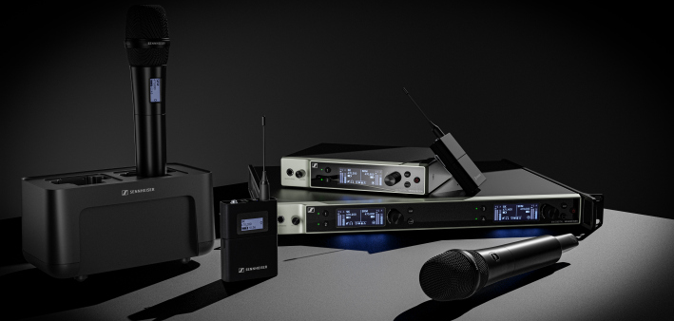

Sennheiser Announces Availability of Additional Components of the EW-DX Microphone System
Two-channel digital half-rack Dante-enabled receiver highlights newest members of the Evolution Wireless Digital family

Wedemark, November 28, 2023 – Sennheiser, the first choice for advanced audio technology that makes collaboration and learning easier, has announced that new components of the EW-DX microphone system are shipping and available to customers. With initial components released last year, EW-DX simplifies professional workflows by utilizing refined technologies to deliver a digital UHF system that can be scaled with ease.

Among the newly available products are a two-channel Dante receiver in a half-rack size, a network charger with cascading, and an active directional wall-mounted antenna. In addition to the new hardware, Sennheiser’s Control Cockpit, Wireless Systems Manager and Smart Assist App software has been updated to include support for the new EW-DX components.

The Two-Channel Dante Receiver
Adding to the two-channel receiver without Dante, Sennheiser now offers the EW-DX EM 2 Dante, a half-rack (9.5”) two-channel receiver, which allows for various network modes to flexibly integrate into existing workflows. The receivers have a switching bandwidth of up to 88 MHz, which can translate – thanks to Sennheiser’s equidistant spacing – to up to 146 channels in standard mode and up to 293 in link density mode.
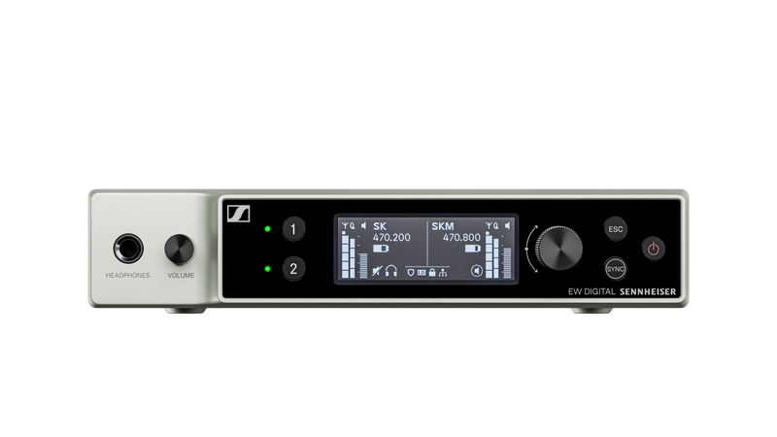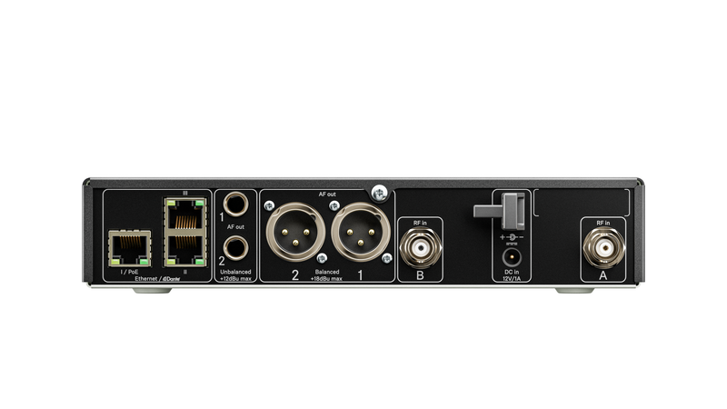Front and back of the EW-DX two-channel Dante receiver

The Network Charger with Cascading
Earlier this year, CHG 70N, a non-cascading variant of the EW-DX 2-bay network charger, began shipping to customers. Today, Sennheiser announces the replacement for CHG 70N, a network charger that can be cascaded (up to 5 x network charger units), named CHG 70N-C.

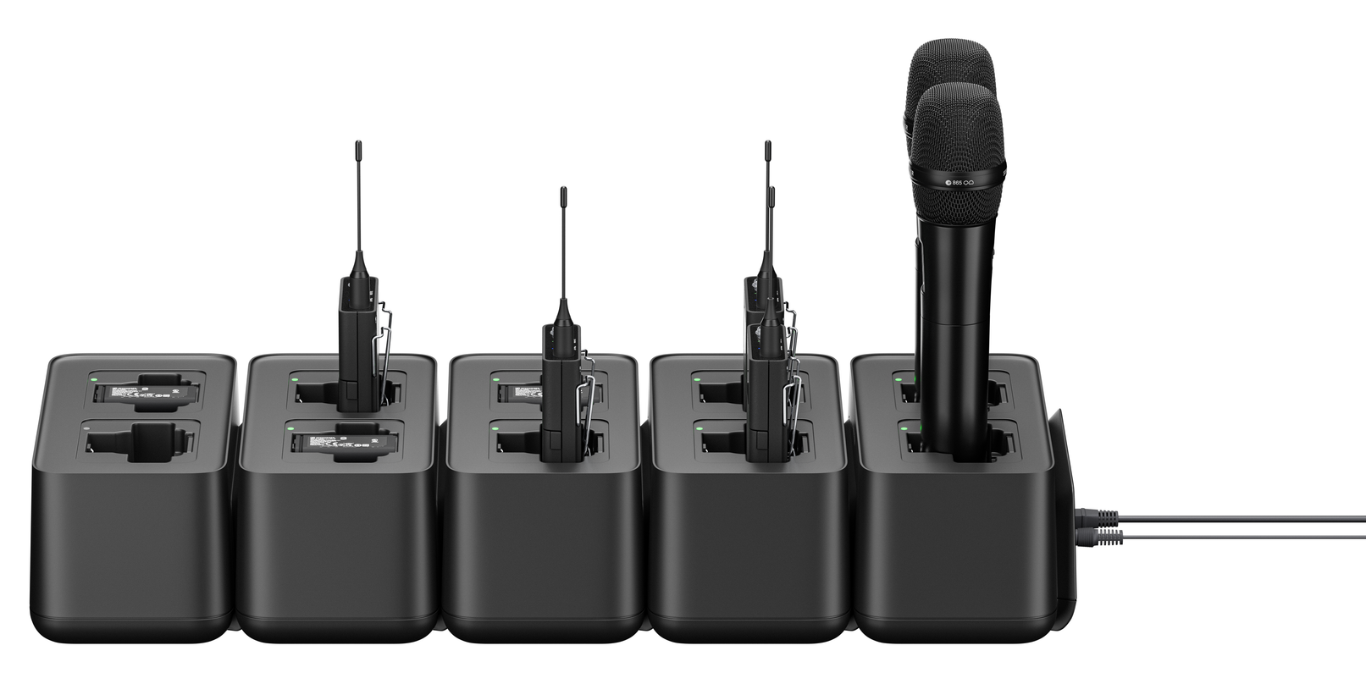 | The new CHG 70N-C cascading network charge

The Wall-Mount Antenna
The AWM wall-mount antenna is an active directional antenna for use with Evolution Wireless Digital microphone systems. It can be connected to any stationary Evolution Wireless Digital receiver or EW-D ASA antenna splitter. AWM is available in the following product variants:

- AWM UHF I (470-694 MHz)
- AWM UHF II (823-1075 MHz)
- AWM 1G8 (1785-1805 MHz)

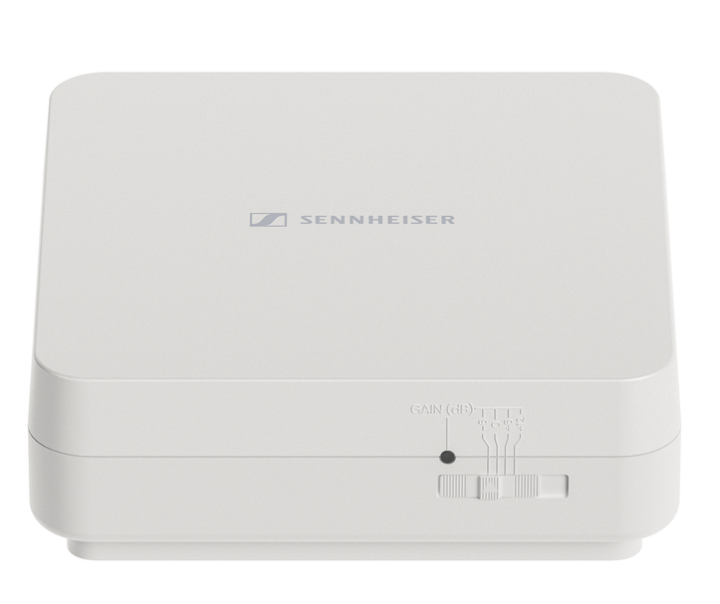 | AWM wall-mount antenna

The Central Software for Easy Handling, Control and Maintenance
Sennheiser offers customers the ability to monitor and control its audio solutions with centralized software for a variety of use cases. For customers using EW-DX in corporate or educational environments during lectures or meetings, Sennheiser Control Cockpit version 7.1.0 now includes support for the following new EW-DX products:

- EW-DX EM 2 Dante Receiver
- EW-DX Table Stand Transmitters (available early 2024)
- EW-DX CHG 70N-C Cascading Network Charger

The easy-to-use Sennheiser Control Cockpit provides a global overview of all network-enabled devices at all times. It shows all status information at a glance and makes setting adjustments for one or multiple devices at the same time very easy.

For operators in multi-channel live audio environments, such as music or theatre performances, the Sennheiser Wireless Systems Manager 4.7.0 supports all EW-DX products for set-up, monitoring and control.

For convenient operation of smaller set-ups, Sennheiser’s new Smart Assist App version 2.1.1 provides automated setup, operation and monitoring using any iOS or Android device. An intelligent setup function automatically creates reliable wireless connections, no wireless expertise required.

The Response from an EW-DX Customer
Creative Technology (CT) is a multi-national provider of technology, project management and creative solutions for the live events and system integration markets, and part of the NEP Group, a leading global broadcaster. Recently, the company’s US-based operation (CTUS) worked with Sennheiser on the design and specification of a comprehensive wireless audio kit that featured its EW-DX wireless system to ensure reliable and superior sounding audio for its customers. CTUS has assembled and deployed 140 custom wireless microphone kits — each with the Sennheiser EW-DX wireless system at its core — to streamline its ability to deliver high-quality audio for mission-critical events across the U.S.A.

“On one of our recent projects, we coordinated over 200 frequencies using the new Sennheiser EW-DX R1-9 and Q1-9 RF bands,” says Jeff Jones, RF Coordinator, Creative Technology. “These units were easy to set up, easy to tune and easy to sync bodypacks and handhelds. Having the two wide RF bands allowed us to tune over the complete available spectrum making the EW-DX units a superior choice to handle the large quantity of breakout rooms versus older generation, band-limited technologies. We had rock solid performance with the new Sennheiser units.”

The Additional Components to Come
In addition to the EW-DX TS 3 and 5-pin table stand transmitters in all frequency ranges, a four-channel Dante receiver with full 19” rack size is expected to be available mid-2024.

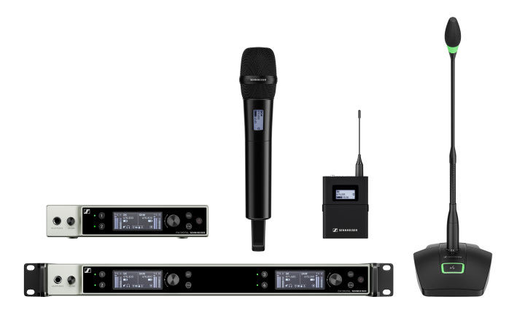
A glimpse at some of the EW-DX system components

“We have already seen great adoption of EW-DX in the market and look forward to helping our current customers build upon their EW-DX systems, while enticing new customers with these new components,” says Michael Altemark, Lead Product Manager Wireless, Business Communications at Sennheiser. “By adding Dante enabled receivers, a cascading charger and support from our multiple software control platforms, we are delivering on our commitment to provide the wireless microphone system features our customers need and demand.”

For more information about EW-DX, please also visit www.sennheiser.com/ew-dx-business or www.sennheiser.com/ew-dx-professional.

(Ends)

Dante is a registered trademark of Audinate Pty. Ltd.
The images accompanying this press release plus additional photos can be downloaded here.

About the Sennheiser brand
We live and breathe audio. We are driven by the passion to create audio solutions that make a difference. Building the future of audio and bringing remarkable sound experiences to our customers – this is what the Sennheiser brand has represented for more than 75 years. While professional audio solutions such as microphones, meeting solutions, streaming technologies and monitoring systems are part of the business of Sennheiser electronic GmbH & Co. KG, the business with consumer devices such as headphones, soundbars and speech-enhanced hearables is operated by Sonova Holding AG under the license of Sennheiser.

www.sennheiser.com
www.sennheiser-hearing.com

Global Business Communications
Press Contact Global Pro Audio Press Contact
Jeff Horan Stephanie Schmidt
jeffrey.horan@sennheiser.com stephanie.schmidt@sennheiser.com
+1 860-598-7539 +49 (5130) 600 – 1275

